**Minimum Difference Between BST Nodes:**

Given the root of a Binary Search Tree (BST), return *the minimum difference between the values of any two different nodes in the tree*.

**Note:** This question is the same as 530: <https://leetcode.com/problems/minimum-absolute-difference-in-bst/>

**Example 1:**

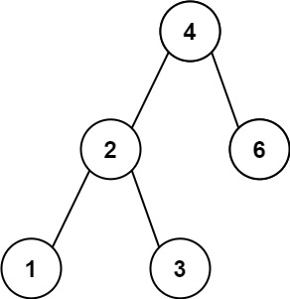

**Input:** root = [4,2,6,1,3]

**Output:** 1

**Example 2:**

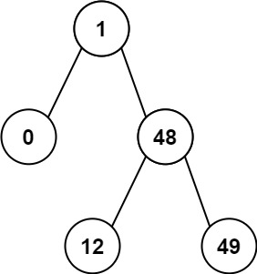

**Input:** root = [1,0,48,null,null,12,49]

**Output:** 1

**Constraints:**

* The number of nodes in the tree is in the range [2, 100].
* 0 <= Node.val <= 105